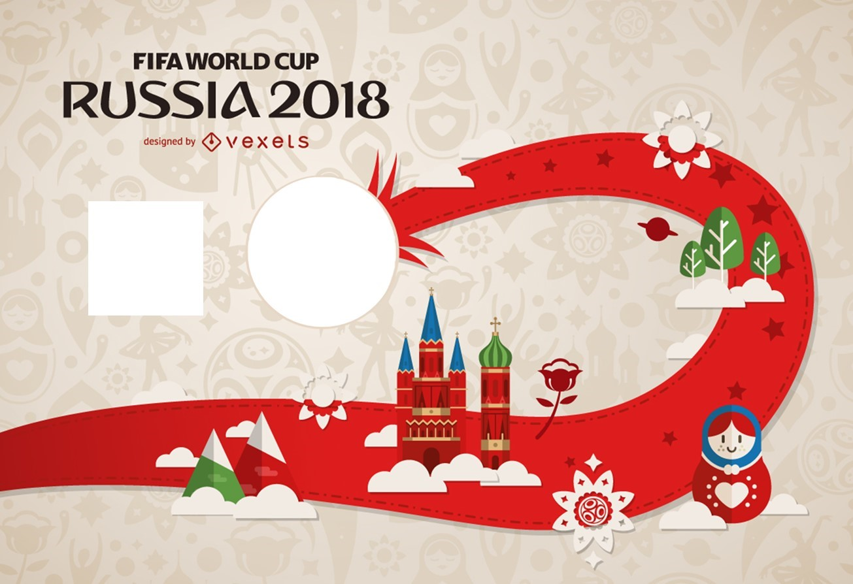

**The Host Cities**

The 2018 FIFA World Cup will be hosted in 12 stadia across 11 cities in Russia:

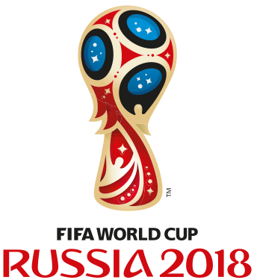

**Host country Russia**

**Dates 14 June – 15 July**

**Venue(s) 12 (in 11 host cities)**

**Teams 32 (from 5 confederations)**

**VENUES**

**BRACKET**

**Round of 16 Quarter-finals Semi-finals Final**

**Group Stages**

The group stage matches will be played between 14th June 2018 and 28th June 2018. They will be played as follows:

















**TICKETS**

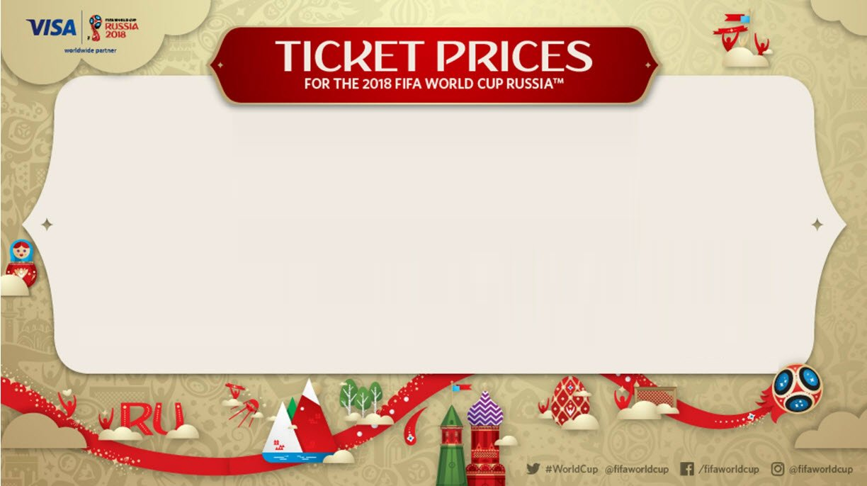

**MATCH　　　　　　　　　　　　　CAT 1　　CAT 2　　CAT 3　　CAT 4**

**OPENING MATCH (N° 1)　　　　　USD 550　USD 390　USD 220　RUB 3 200**

**GROUP MATCHES (N° 2 TO 48)　　USD 210　USD 165　USD 105　RUB 1 280**

**ROUND OF 16 (N° 49 TO 56)　　　USD 245　USD 185　USD 115　RUB 2 240**

**QUARTER-FINALS (N° 57 TO 60)　USD 365　USD 255　USD 175　RUB 3 800**

**SEMI-FINALS (N° 61 TO 62)　　　USD 750　USD 480　USD 285　RUB 4 480**

**3RD/4TH PLACE MATH (N° 63)　　　USD 365　USD 255　USD 175　RUB 3 800**

**FINAL (N° 64)　　　　　　　　　USD 1100　USD 710　USD 455　RUB 7 040**